15 Simple Ideas to Make a House a Home
Your house should make you feel welcomed as soon as you step through the door, but this feeling isn't something that always happens on its own. Once the movers have left, and the chaos of moving has calmed down, it's time to start focusing on putting down roots in your new space to help make your new house a home.
There are many ways to invoke the cozy, warm feeling that makes a house a home without a complete remodel or shopping spree. So, whether you just moved into your new home in Boston, MA, or need to personalize your studio in Albany, NY, here are 15 simple ideas you can use so your house can start feeling like a proper home.
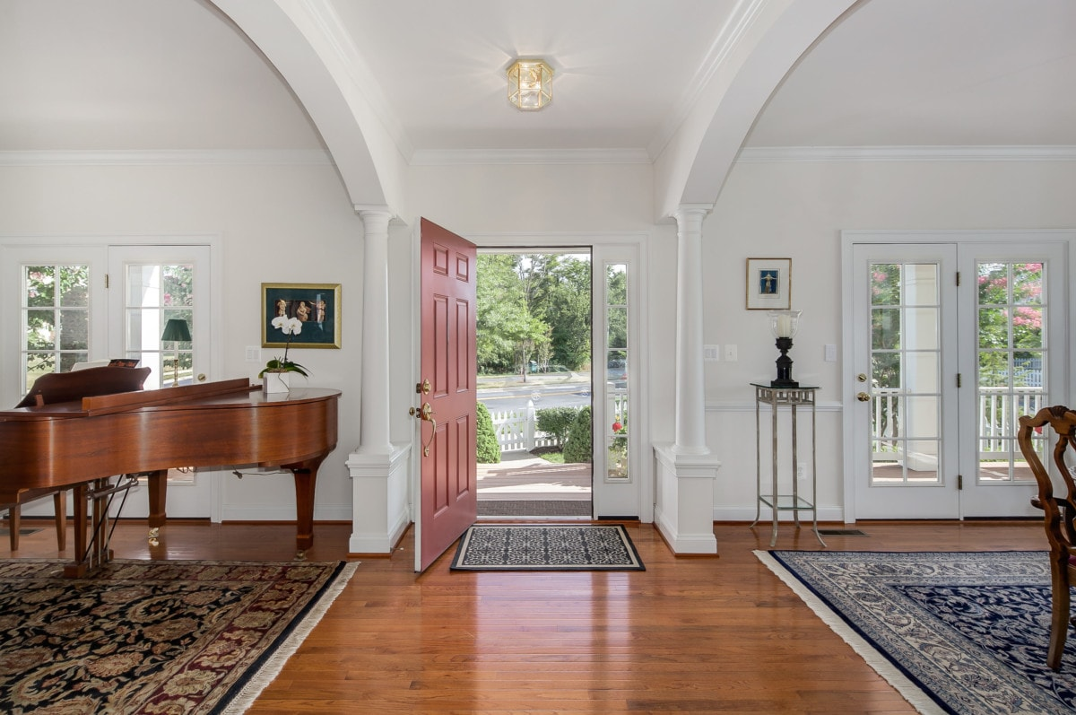

1) Create an inviting entryway
The front door and entryway can set the mood of your entire home. After all, it's the first thing you see when you and your guests first step into your space. Make your front entrance more inviting by keeping it clear of leaves and debris and accessorize with a welcome mat and a few potted plants. Adding a bench or a clothes rack will also help keep your entryway neat and tidy, plus it makes a great first impression. Equally, painting the front door can give your house a fresh, new look in one afternoon. Feel free to choose a fun, contrasting color that aligns with your style.

2) Make your home more zen
Turning your house into a home starts with ensuring that you feel instantly at peace when you enter a room. But if you're having difficulty feeling relaxed, there may be particular reasons why. If the sight of a messy, disorganized room is causing you stress, you might want to start decluttering and letting go of items that don't bring you joy. Choosing random decor items to fill up empty spaces in your home can make a space feel cramped, and can add too many contrasts between your wall colors or furnishings. When choosing decor, artwork, or pictures, be sure to pick items that have special meaning to you. By identifying the areas in your home causing you stress, you can begin making your home a more zen space.
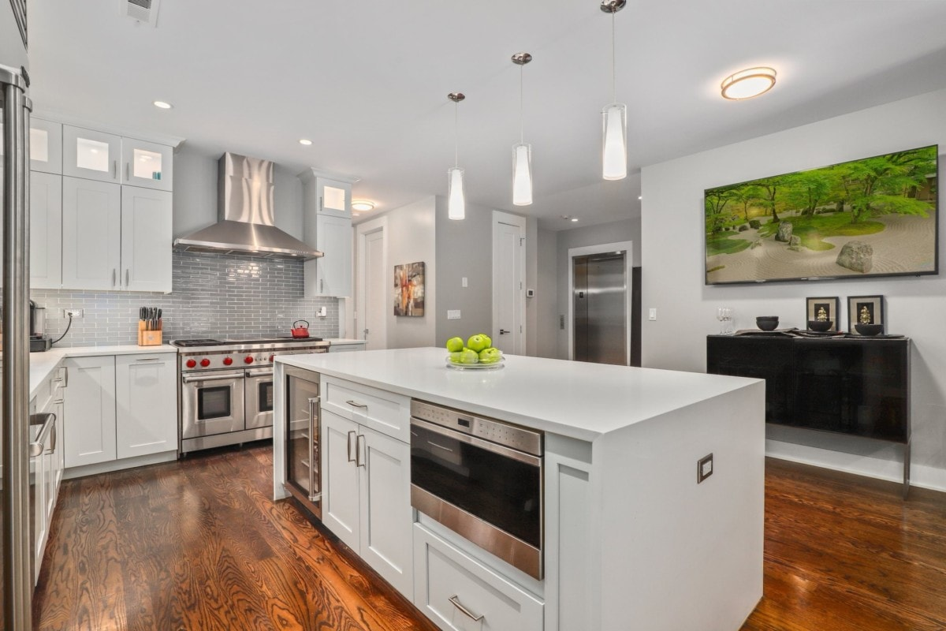

3) Improve your living space with home upgrades
Upgrading spaces in your home can go a long way in making you feel more settled. Bathrooms and kitchens are high-traffic areas in a home, so prioritizing home upgrades in these areas can ensure that you're tackling the places that make the biggest impact. Installing new appliances can give your kitchen a facelift, but if you're working with a smaller budget, select the most outdated or worn-looking one and replace it. Likewise, swapping out an old showerhead with one that has better water pressure can instantly elevate space and improve the quality of life in your home.

4) Use cozy area rugs to help make a house feel like home
An area rug can instantly warm up a space and make it more inviting. Area rugs can help ground furniture, and an artistically designed rug can also add more interest to a space. When selecting a rug, take the room's size and arrangement into account. Ensure all of your furniture is on the area rug or at least touching a portion of the rug to give the space a cohesive look.

5) Dress up empty walls with artwork
Blank walls can add an unfinished element to your house, preventing your house from feeling truly lived in. Displaying your favorite pieces of art can act as the finishing element to pull a space together and make a house a home. And the best part is that it's a budget-friendly way to complete a room. When selecting your artwork, keep the room's function, size, and decor style in mind. After that, you have the freedom to choose artwork that you love and will be happily displayed in your home.
For living rooms and areas where guests spend the most time, choose a large-scale piece as a focal point or incorporate multiple art pieces into a gallery wall. Pieces with soothing, cool-toned colors and abstract prints are great additions for areas for relaxation like a den or bedroom.
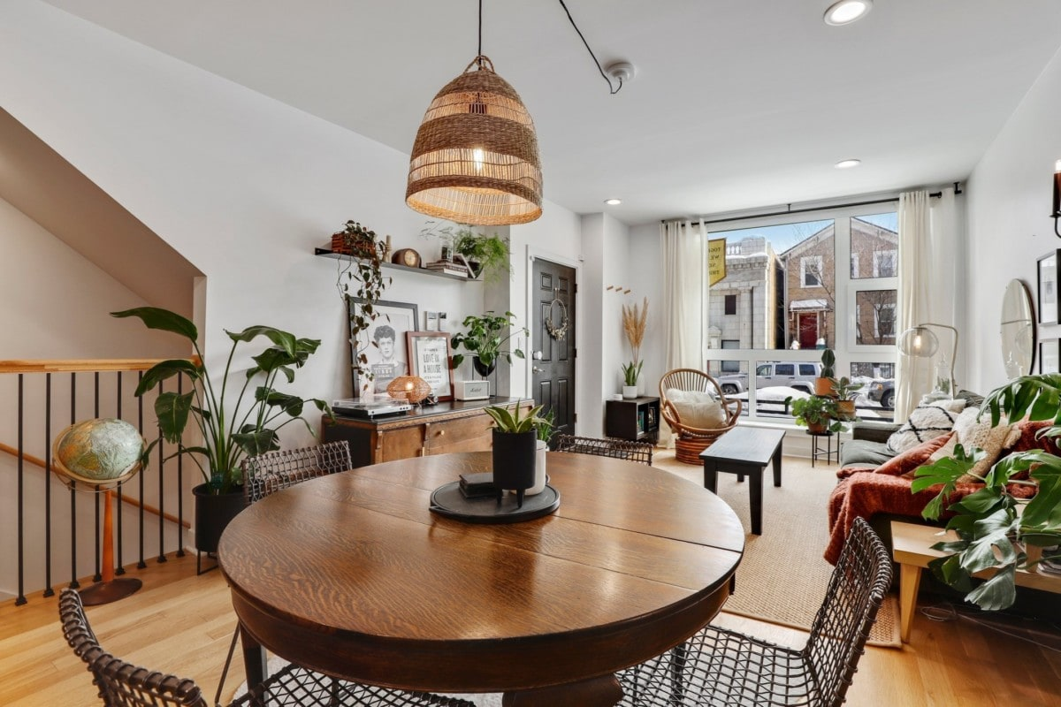

6) Bring nature inside with indoor plants
Indoor plants don't just add a pop of greenery to a space, they can also breathe life into a dull room. Houseplants help us feel more relaxed and can even improve our home's indoor air quality. They come in various shapes, colors, and sizes, so if you live in a shady studio in Portland, OR with only a few windows, or a home with lots of natural light in Seattle, Washington, you can still find ways to incorporate plants into your decor.
For home offices or areas with low light in your home, stick to low-maintenance plants like lucky bamboo or succulents. These plants are compact enough to keep on a desk or side table and thrive in shaded areas. To add drama to larger rooms, such as living or dining rooms, money trees or fiddle leaf figs are great statement plant options. Plus, the right planter can add another design element to your home.

7) Keep the clutter to a minimum
Identifying the key areas in your space that you'll keep tidy will make life in your home more pleasant. It's easy to believe in the "out of sight, out of mind" mentality when decluttering, but actively keeping your living area clean will allow you to fully relax in your space without being constantly stressed by the sight of messy areas. Instead of stowing items that are no longer used in designated "junk drawers," take the time to go through and pick out items that no longer have sentimental value, use, or have similar functions to items you already have. And if the thought of decluttering your home is too daunting, consider hiring a professional organizing service to help you get your space in order.

8) Add scented candles or diffusers
A house filled with inviting smells can instantly make a house feel like home. With various candles, diffusers, and scent plug-ins available on the market, there's no shortage of ways to make your home smell good. Choose your favorite and fill your home with the aroma of sweet vanilla, sharp citrus, or fresh linens in minutes. For more natural smelling scents, you can opt for essential oils, such as lavender or jasmine, which comes with the benefits of being natural stress relievers.
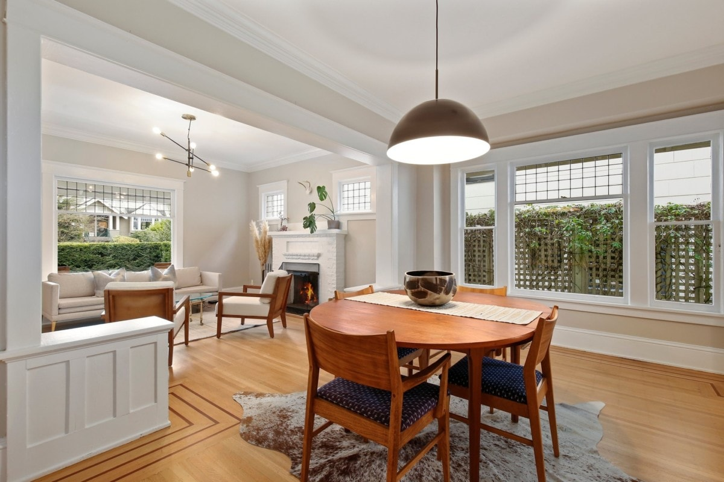

9) Make a house a home by layering the lighting
Lighting plays a significant role in affecting a room's mood and is an essential design element when making a house feel like a home. If your house feels dark and cramped, you can switch up your lighting by adding and layering light sources to make it feel more warm and welcoming. While brighter lights are needed to illuminate kitchens and workspaces, using fluorescent overhead lighting in living rooms or dens can make the space appear harsh. Instead, opt for ambient light sources that use mellower, warmer lighting. Wall sconces, table, or floor lamps are excellent ambient lighting sources that can cast a warm, cozy glow on any room.

10) Frame your windows with curtains
Window curtains are great accent pieces in a room. Replacing them is an easy way to switch up the room's look and add a lived-in look to any space in one easy step. Personalize your windows by adding new window dressings to instantly warm up your home and showcase your style. Not only does adding beautiful curtains or shades improve your home's appearance, they can also decorate blank walls, separate a room into sections, or even create fun little reading nooks in children's bedrooms.

11) Showcase family mementos or antiques
Make your house feel like home by incorporating sentimental pieces in your decor, such as family mementos or antiques, to personalize your space. As you plan the display locations for your keepsakes, group related items together to help create a cohesive look in your home design. Items such as wedding photos, important documents, or certificates can be grouped in a gallery wall, while trophies or souvenirs can be displayed on a shelf together.
When displaying sentimental photos, pick frames that can protect the paper from damage or fading from ultraviolet (UV) rays over time. If you're planning on including antiques or other precious items as decor, consider purchasing shadow boxes or display cases for them. Cases will protect the objects from harm and prevent dust or grime from settling on the fragile objects.
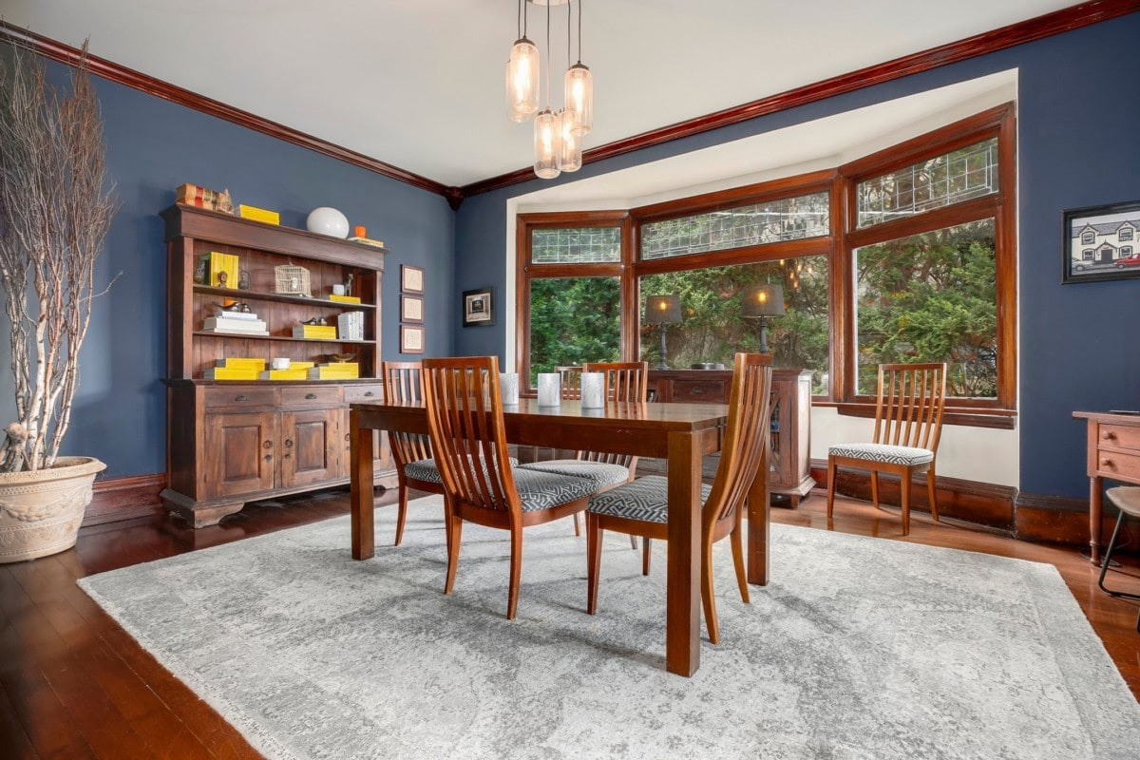

12) Freshen up your home with a coat of paint
Painting your walls can give your space an instant facelift and can go a long way in refreshing a home. Plus, it's a great way to customize your home and make it your own. If you're not ready to undertake an entire painting project, you can pick smaller areas in your home, like a bedroom or powder room. You can even opt to paint a few accent walls throughout your home to warm up the space and give it pops of color.
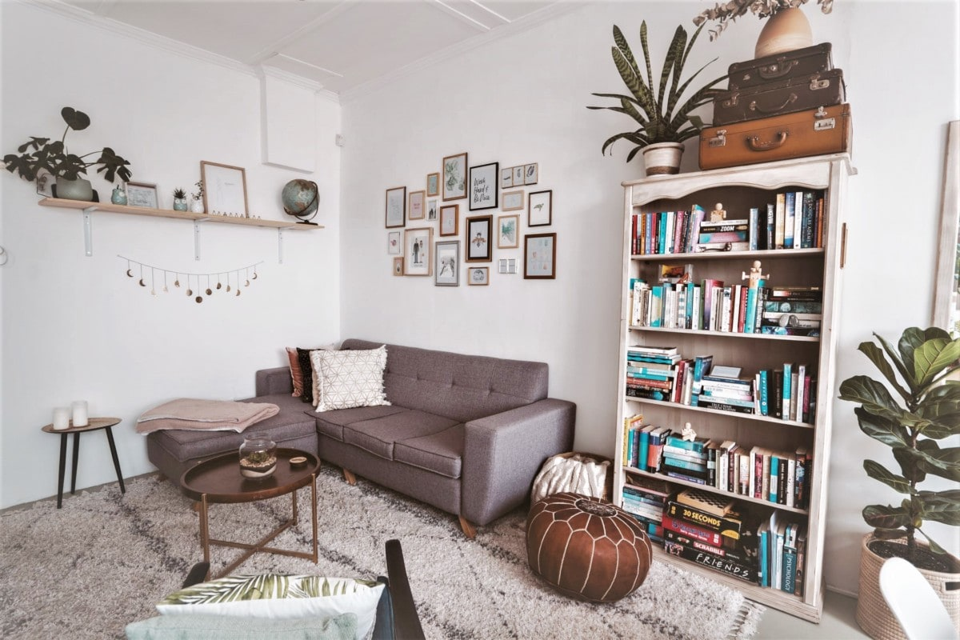

13) Personalize your shelves with books
A stack of well-loved paperbacks or a decorative coffee table book is a great way to bring personal touches into your home. Books are an easy and budget-friendly way to embellish your decor and can be used as statement accessories to pull a space together. And, the sight of a filled bookshelf can instantly give a room a homey feel. If you have an extensive book collection, use a blank wall in your home to create a book wall by displaying them in a floor-to-ceiling bookshelf. You can also choose books with decorative covers or colorful spines to brighten up your decor.
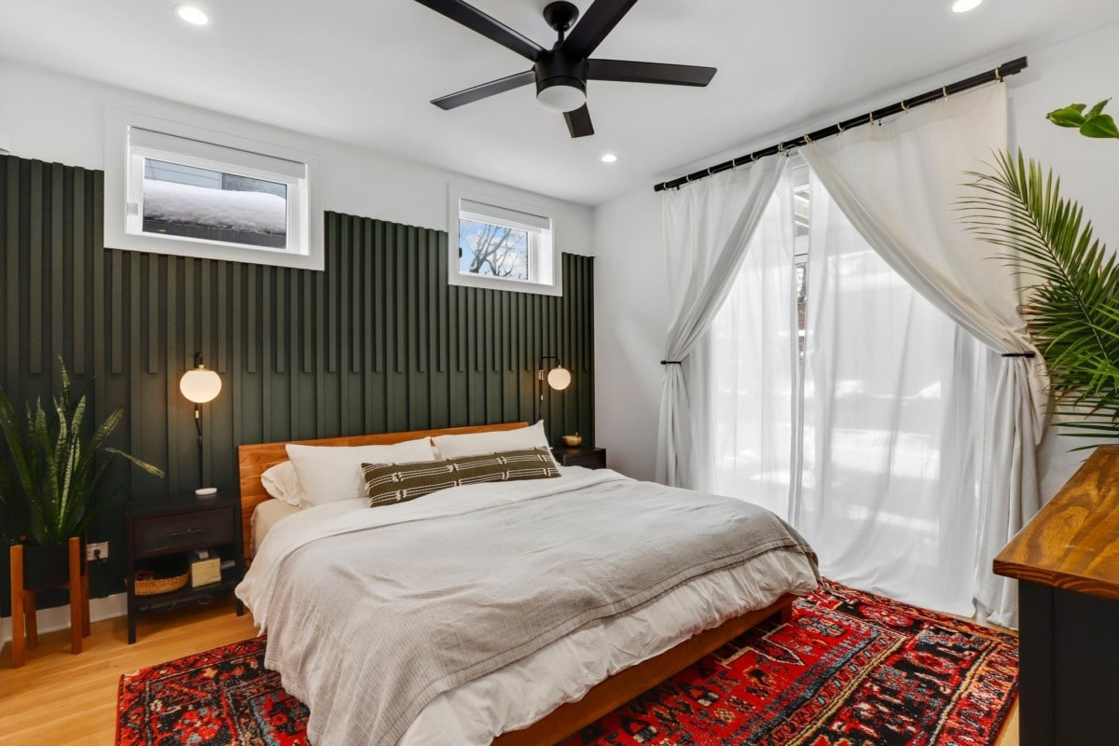

14) Add warmth with comfy bedding
The right bedding can instantly make your room look decorated and homey if you can't decorate the whole room right away. If your room has a bold paint color, using neutral-colored bedding can add texture while also creating depth and interest to your space. Alternatively, if your room has a neutral color palette, you can play around with different colors or patterns in your bedding.
When creating the ultimate comfy bedroom, one can't forget the textiles to transform a bare bedroom. Adorning your bedroom with soft throws- chenille or faux fur are great options - and fluffy pillows can instantly add a cozy touch to any space, making your bedroom feel more welcoming.

15) Finally, make a house a home by setting up a hobby area
Whether your hobby is painting, reading, or even solving puzzles, make room for it. Dedicating a space in your home, like a nook or bonus room, for your hobbies will not only make it easier to do what you love, but it allows your personality and interests to shine throughout your home. Not to mention, having an area to yourself can allow you to concentrate on doing what you love all while making your house feel more like a home.

Originally published by Redfin

